**Determinism Tests setup guide for CARLA**

**Abanoub Ghobrial, Greg Chance, Kerstin Eder**

**1) Install CARLA:**

Follow CARLA’s docs to install Unreal Engine 4 (version 4.22) and Carla (version: 0.9.6 ) on Ubuntu 18:

<https://carla.readthedocs.io/en/latest/how_to_build_on_linux/>

**2) Import map:**

You will then need to import in our map, because the tests are designed to run on our map.

**a)** Copy files from drive in:

*CAV-Determinism /CARLA_Tests_setup_guide/Import_map/Plugins*

To this folder in CARLA:

*~/carla/Unreal/CarlaUE4/Plugins*

**b)** Copy the “loop_geo_RHD” folder from drive in:

*CAV-Determinism /CARLA_Tests_setup_guide /Import_map/Map*

To this folder in CARLA:

*~/carla/Unreal/CarlaUE4/Content/Carla/Maps*

**c)** Copy the “loop_geo_RHD.bin” file from drive in:

*CAV-Determinism /CARLA_Tests_setup_guide /Import_map/Map*

To this folder in CARLA:

*~/carla/Unreal/CarlaUE4/Content/Carla/Maps/Nav*

**d)** Copy the “loop_geo_RHD.xodr” file from drive in:

*CAV-Determinism /CARLA_Tests_setup_guide /Import_map/Map*

To this folder in CARLA:

*~/carla/Unreal/CarlaUE4/Content/Carla/Maps/OpenDrive*

**e)** Then import the map by following the importing steps on the Carla docs:

<https://carla.readthedocs.io/en/latest/how_to_make_a_new_map/>

**f)** After completing this you should find the “loop_geo_RHD” map in:

*~/carla/Unreal/CarlaUE4/Content/Carla/ExportedMaps*

**e)** Now open the level and press the Play button. If you find there is a lighting problem, and the scene goes all dark. Then please follow the guide on this issue: <https://github.com/carla-simulator/carla/issues/3426>

**3) Tests:**

**a)** There are three tests outlined in Table 1, each of them has an option to run with or without a crash happening... totaling to **6 tests** in total!! Table 1 also includes the crash type i.e. between which actors.

|  |  |  |
| --- | --- | --- |
| Test ID | Test description (see Fig 1) | Collision type |
| 001 | Two vehicles | Vehicle and Vehicle |
| 002 | Two vehicles and a pedestrian | Vehicle and Pedestrian |
| 003 | Two pedestrians | Pedestrian and Pedestrian |

Table 1: Set of experiments

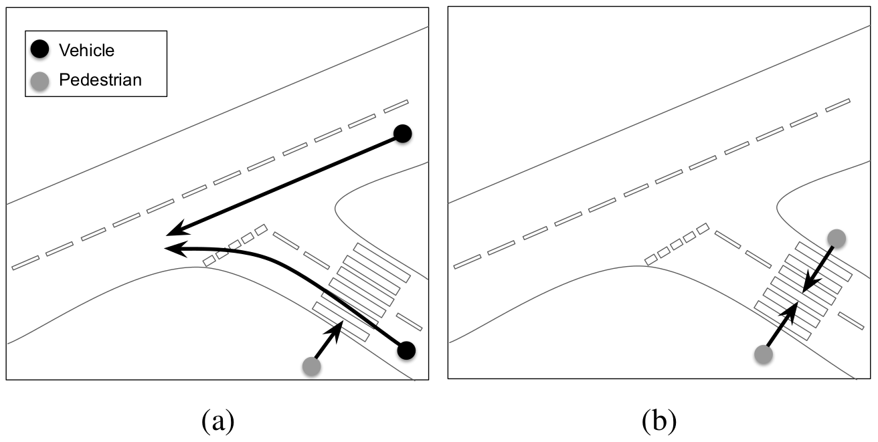

Fig1: Shows the setup of the different tests in Table 1, (a) Test IDs 1 and 2 (b)Test ID 3.

**b)** Copy the “ROBOPILOT_Determinisim_V1.py”, “live_plotter.py”, “cutils.py” python scripts and the “ExperimentsInputs” folder from the drive in:

*CAV-Determinism /CARLA_Tests_setup_guide /Running_tests*

To this folder in CARLA:

*~/carla/PythonAPI/examples*

Also create an “ExperimentResults” folder in:

*~/carla/PythonAPI/examples*

**c)** Now everything is setup to run the tests

**4) Running Tests:**

**a)** Launch CARLA by running *make launch* in the terminal command in *~/carla*.

**b)** Once launched, navigate to the loop_geo_RHD map, open it and press on the play button (Highlighted in the screenshot below). If you get a lighting issue and the scene goes dark, then please refer to **2)e)** on this guide**.**

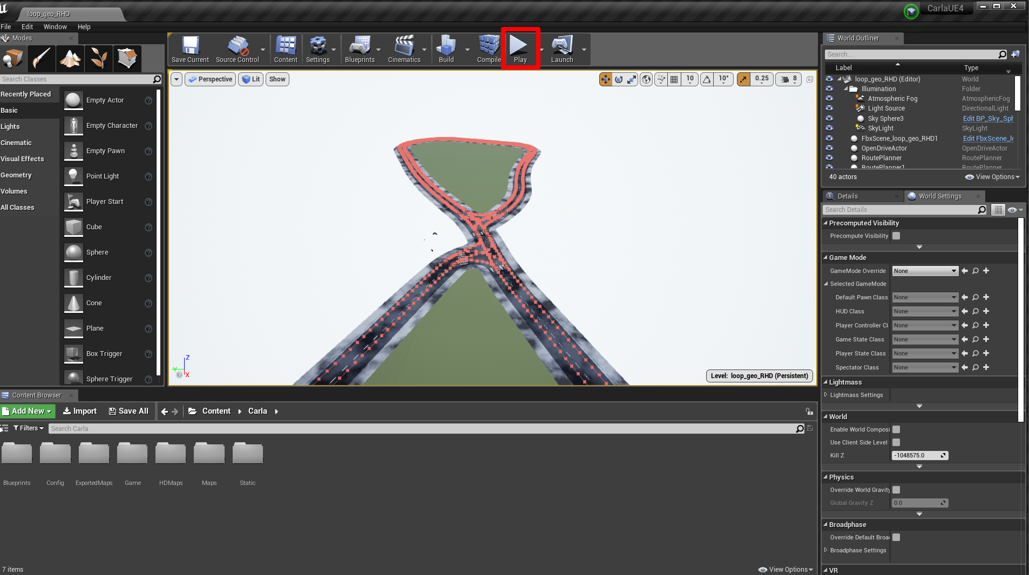

**c)** To execute the tests open a terminal and go to:

*~/carla/PythonAPI/examples*

**d)** Run:

*python3 ROBOPILOT_Determinisim_V1.py*

The below are the available flags that you will need to use:

-TestID choose from 1,2 and 3

-crash choose if you want test to run with collision

-nocrash choose if you want test to run without collision

-n choose the number of runs (repeats) for the test

-OF enter the output file name you want for the log file. We suggest that you mention the flags, numbers, the machine used to run the test and any other important info in the log file name.

Example: To run Test ID 2 with a crash, repeat it for 1000 times and output the log file name as “TestID2_trial_output.txt”; the terminal command would be as shown in the screenshot below:

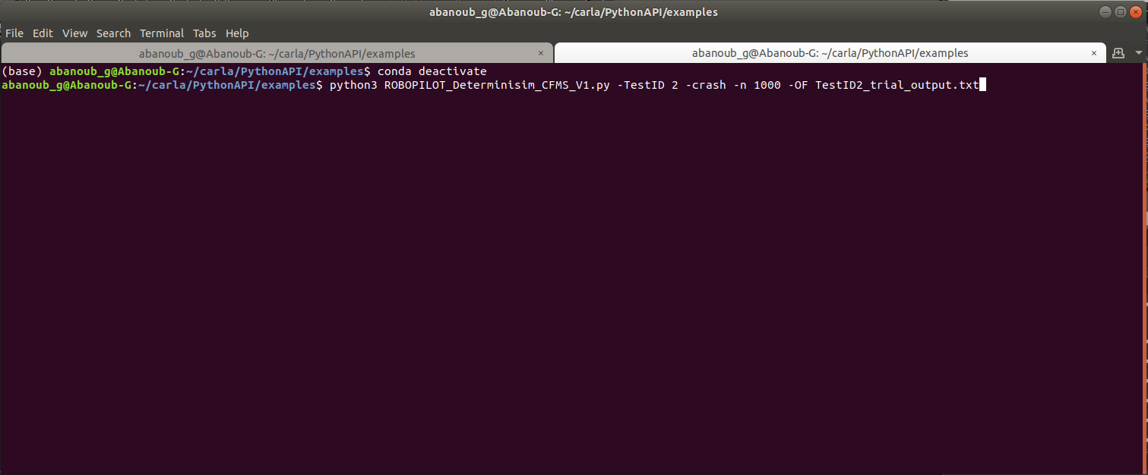

**5) Output:**

The script outputs two numbers (displayed in the terminal command) and a log file (saved in the Experiments Results) after the tests are finished.

The two numbers show the Mean deviation and the Max deviation respectively. See screenshot below:

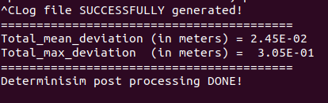

**6) Additional Comments:**

**a)** We suggest that you do at least 1000 runs per test for each of the 6 test.

**b)** Running in headless mode:

There are two approaches for that in carla:

**i)** Run in no rendering mode. (no rendering mode) Easy to implement but useless since in this mode, cameras and other GPU-based sensors return empty data in the simulator. I.e. not applicable for autonomous vehicles testing hence not interesting.

<https://carla.readthedocs.io/en/latest/configuring_the_simulation/#no-rendering-mode>

**ii)** Running without display and selecting GPUs. (headless mode) This is potentially more what would be useful for mass testing of autonomous vehicles. We think this method doesn’t have the sensors empty arrays problem that exists in the “no rendering mode”. We have not tested this headless mode, Please find link below for further info:

<https://carla.readthedocs.io/en/latest/carla_headless/>